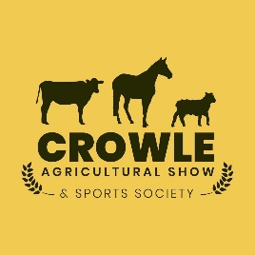
ENTRY FROM
CATTLE & SHEEP SECTIONS
Closing Date: 15th July 2022
Competitors must comply with Crowle shows Defra Biosecurity Plan.
All fees must be paid at the time of entry.
Entry fee: £5.00 for Cattle per class, £3.00 for Sheep per class (exc. Young handlers). Please still include young handlers below.

Class No. | Name of Animal  Not Applicable for Sheep  For young handlers, please name here. | D.O.B  Optional for sheep | Eartag Number  Not Applicable for Sheep (movement forms on the day) | Breed | Fee
TOTAL £

All exhibits must arrive on the show field no later than 10:30AM. Judging commences at 11:00AM prompt, no exceptions. Exhibitors can leave from 4:00PM
Entries to: Olivia Parkin, Bridge House Farm, Crowle Road, Eastoft, North Lincs, DN17 4PL Cheques made payable to: Crowle Show
BACS: Crowle Agricultural Show & Sports Society Sort Code:101332 Account Number: 51053760
For more info, please telephone David Parkin on 07714 650 092.

Name: ___________________________________________Address: ___________________________________________________________________________
___________________________________________________________________________ Postcode: _______________________________________________
Tel: _________________________________________ Email: _________________________________________________________________________________

